Campaign finance is such an important issue in the United States because it is seen as an undermining Democracy. Proponents argue that our representatives are supposed to be representing all of us, not just the few that can afford to support their campaigns with large donations, and so those of us without deep pockets get less real influence. Those in favor of the current system argue that spending one’s money is simply another form of free speech, ad that candidates are not beholden to their contributors in practice. However, despite its importance, the media often focuses on the polarization of the issue and fails to provide quantitative data that might actually lead to discourse for a compromise, or settle the issue. Not only is this non-productive, but it makes it much more difficult for the average American to get their hands on cold, hard, facts. Furthermore, data sources are disparate, and in some cases, intentionally opaque.

With all of this in mind, we set out to find that data and get those facts. Questions that we hoped to answer included: How much influence does campaign financing really have over the outcome of elections? Can it be quantified? Can we see the “favors” resulting from contributing to a candidate materializing as gains after their election? Do any or all of these questions vary by political party?

Our primary data source became Open Secrets, a research group whose mission statement includes tracking money in U.S. politics. From Open Secrets we were able to obtain data covering the funding of elections every two years from 2004 to 2014. In particular, we were able to obtain contributions by industry (as long as they were large enough to be required to be reported to the government) for every year-election-candidate combination. For election results information, we gathered federal filings to the Federal Election Committee (FEC) for 2004-2012. The 2014 results were unavailable, so they were obtained from the New York Times Election Tracking website. Finally, industry stock data was collected from Yahoo Finance via Quandl, with an eye towards tracking industry performance across elections.

For the majority of the analyses below, we do not use the full dataset constructed from the sources above, but instead use a more limited data set of what we would call “typical” candidates. To give some examples of the “a-typical” candidates that were removed: 1) Uncontested candidates, since without an opponent there would not be as much pressure to fund raise, therefore they would be a distinct group from the majority in funding practices. 2) Candidates that ran but received a very small percentage of votes (there are candidates that ran but received only 5 votes, such as write-ins). 3) Clear outlier candidates with such a vast percentage of funding in their race as to eschew a typical funding distribution.

Question 1: Do campaign contributions predict electoral success?

Our analysis found that campaign contributions are highly correlated with electoral success, both in terms of amount of funding and percentage of total funding in a given race received. The correlation coefficient between the percentage of funds received and the percentage of votes received is .87; for every additional percentage point of funds a candidate raised, he/she received an additional .87% of votes. In the graph of percentage of funds raised, it is clear that there are stark differences between the winning and losing candidates, with only a small bit of overlap.

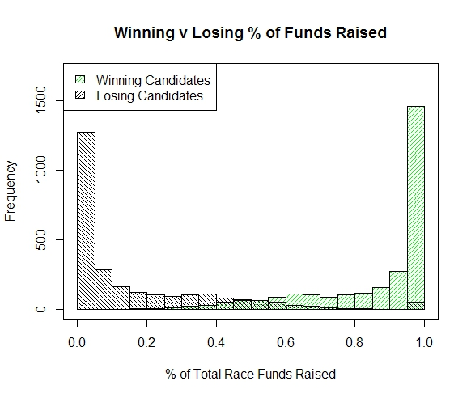

This result was supported by the frequent itemset mining analysis. For this portion of the analysis, funds raised was binned into four categories (very low, low, mid-high, and high). Candidates who received a very low amount of funding tended to be election losers, while candidates who raised a high amount of funding tended to be election winners.

After concluding that campaign funding was highly correlated with electoral success, we ran some predictive analyses to determine how effective the campaign funding variable was in determining election winners. We set up a logistic regression model in which the winner variable was determined solely by the amount of money raised and the number of industries that contributed to a candidate, and found that these two variables alone gave us a classification rate of 81.8%, with most of the predictive power coming from the funds raised variable. We were a bit surprised by the high classification rate; although we came into the project with the idea that funding played a role in election outcomes, we were not expecting it’s impact to be so large.

We wanted to see if we could develop an even more accurate predictive model, so for the decision tree analysis we added the incumbency status variable. The prediction accuracy improved to about 90%, but, as the tree below shows, the incumbent variable dwarfed both other variables; once the model had a candidate’s incumbency status, nothing else was important in determining the outcome of the election. Basically, what is happening here is the incumbency variable subsumes the contribution amount; incumbents raise higher amounts of funding than non-incumbents, and since the incumbent variable is such a good predictor of winners on its own (over 90% of election winners in our dataset were incumbents), adding more info on top of the incumbency status doesn’t add any predictive power.

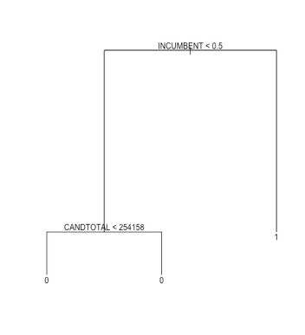

However, the fact that incumbency status is a better predictor of electoral success than amount of funding does not mean funding is meaningless. It is abundantly clear that the more money a candidate raises, the higher that candidate’s chances of being elected. An interesting extension of this analysis would be to closely examine outliers; candidates who raised a great deal of money yet still lost and candidates who raised very little money but were elected anyway, to see how they differ from their counterparts.

Question Two: Does electoral success lead to quantifiable benefits for contributors?

So far, through our exploration of campaign financing and how that should color our views on campaign financing, we showed that there does seem to be a strong, positive association between campaign contributions and electoral success. However, this is only part of the narrative in support of campaign finance reform. Proponents of campaign reform also argue that due to the vast sums of funds involved, the candidate becomes indebted to her largest backers. As a result, the candidate pays back those debts through kickbacks in the form of favorable policy proposals and other legal treatment. This question does its best with the data at hand to address that argument.

In the exploratory stage of answering this question, we investigated the straight correlations between industry performance, votes received, and the percentage of race funds received (the latter two being good proxies for the winner, as shown in Question One).

Unfortunately, since the correlation showed almost no relationship, this was not a good sign for the analyses to come. However, undeterred, we continued our analysis of the financial data by comparing performance in election years to non-election years in the hopes of finding some difference or boost in performance.

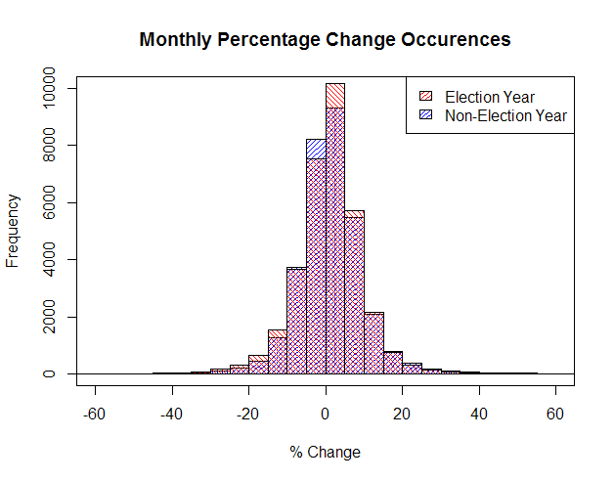

More bad news! Since the monthly percentage change in stock value doesn’t seem to be related at all to the election cycle, it looks like there may be less influence than we had hoped. However, perhaps there is something we are missing about the relationship between candidates and industries that might be able to help us parse the data further.

With that in mind, we analyzed the relationships between industries and candidates using a network. We did this on the full data set without outliers. The following network shows a subset of winning Senators from 2014 as nodes. Connections are formed between candidates that shared at least one of their two top contributing industries.

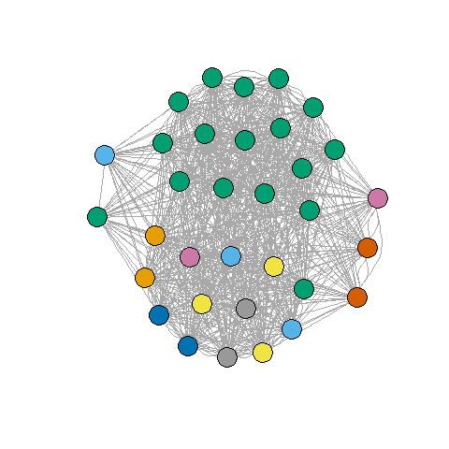

The main take-away from this network is that the candidates are hopelessly intertwined by industry. One possible conclusion from this network is that industries hedge their bets and support many different candidates to be sure they end up on the winning side in one way or another. However, a more likely explanation in this case is that our data is just not good enough for this sort of analysis. The bins are just too coarse to find the relationships that we are hoping to find. The coarseness comes directly from the binning of the Open Secrets data in order to allow it to merge to the financial data. Given these disappointing results, it seemed better to focus our effort on expanding our other research questions.

Other methods that we considered for exploring the chain of campaign contribution to election to contributor gains, but couldn’t complete due to the form of our data, included “What are the time series effects of an election and industry contributions?”, “What is the influence of Super PACs and individual contributions on campaign success?”. Unfortunately, we simply don’t have the granularity of when contributions are made in order to assess time series relationships. The only time series data that we had was the stock data. In the case of the second question, although Open Secrets has PAC and individual contribution information, it was not in a scrapable form and their API restricts accesses to a limited number of records per day. Furthermore, even if we had setup a strategy for gathering that information, it was only available for one or two election cycles.